* VM Memory set to 7Gb so that Scala can have 5Gb for its use.
* Increase Swap space to 2GB
  + <https://bogdancornianu.com/change-swap-size-in-ubuntu/>
  + Count = 1
* **export _JAVA_OPTIONS=-Xmx5096m**
* Launch Scala
  + 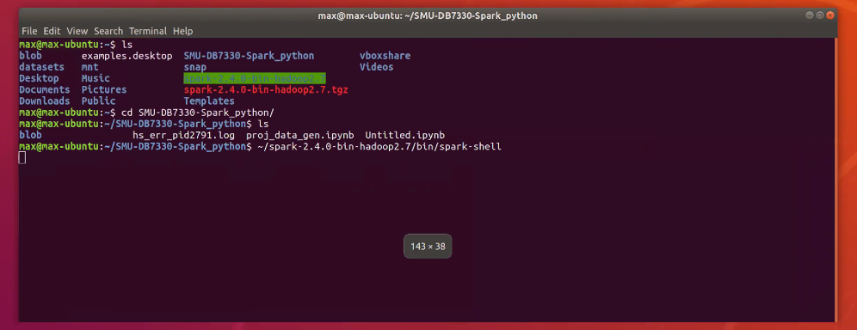
* Run code
  + 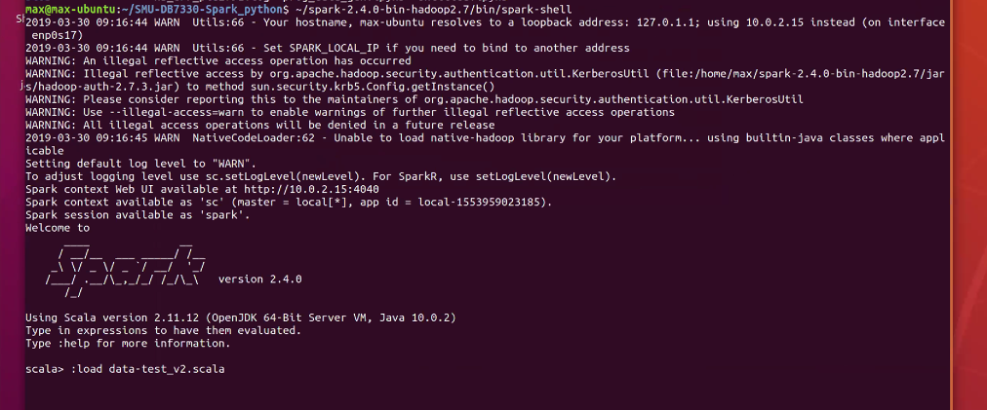

|  |  |
| --- | --- |
| On Linux: Monitor: Swap history will go to 100% that is fine. | **On Windows**  Monitor Disk – it should **not go to 100%** |